Final Project Report
The Port Authority Bus Terminal Passenger Prediction
Students: Aigerim Zhumanalina, Manjil Adhikari,
Sai Karthik Madari, Sai Sachit Tadinada, Swami Vargala
Group number: 5
Class number: BANL-6430-01
Date: 12/15/2025

Team Member Name | Contribution
Aigerim Zhumanalina | Developed the data cleaning strategy, planned dataset integration, and prepared project documentation
Manjil Adhikari | Designed the data model, including table joins and relationship structures
Sai Karthik Madari | Planned and structured the data pipeline and ETL workflow
Sai Sachit Tadinada | Conducted external dataset research and prepared forecasting-related data
Swami Vargala | Synthesized the final dataset and led report writing and editing

- Project the number of passengers for the bus terminal from 2026 to 2030.
Peak Projected Load in 2029: The highest passenger volume is projected to occur in 2029, with an anticipated 10.21 million passengers.
Significant Year-over-Year Growth: There is a substantial and steady year-over-year increase in projected passengers from 2026 (6.41million) to 2029 (10.21 million), suggesting a rapid ramp-up in the demand and utilization of the new staging facilities.
2030 Data Caveat (Partial Year): The projected figure for 2030 (6.11$ million) is significantly lower than 2029. This is due to the dataset containing only a partial year of forecast data for 2030, and not a full 12-month projection.
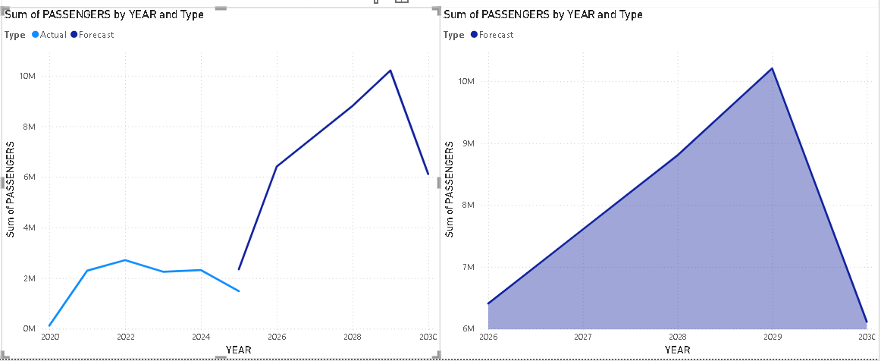

Massive Escalation in Required Capacity: The forecast period shows an unprecedented surge in demand. Passenger volume is projected to jump by over 200% from the last full historical year (2024 at 2.3$ million passengers) to the first year of the forecast (2026 at 6.41$ million passengers).
Critical Peak Capacity in 2029: The absolute maximum passenger load the facility must be prepared to handle is projected to occur in 2029. The annual passenger count for this year is projected at 10,207,606
Contrast with Historical Baseline: The current passenger numbers are historically low, still reflecting the impact of the pandemic. After a severe drop in 2020 (0.12$ million), usage plateaued at a modest recovery level, hovering between 2.3$ and 2.7$ million passengers. This low historical baseline sharply contrasts with the predicted growth, underscoring the magnitude of the future expansion required.

- What are the most important factors in predicting the number of passengers for the bus terminal?
Number of Buses The number of buses is the single most important numerical factor for predicting passenger count.
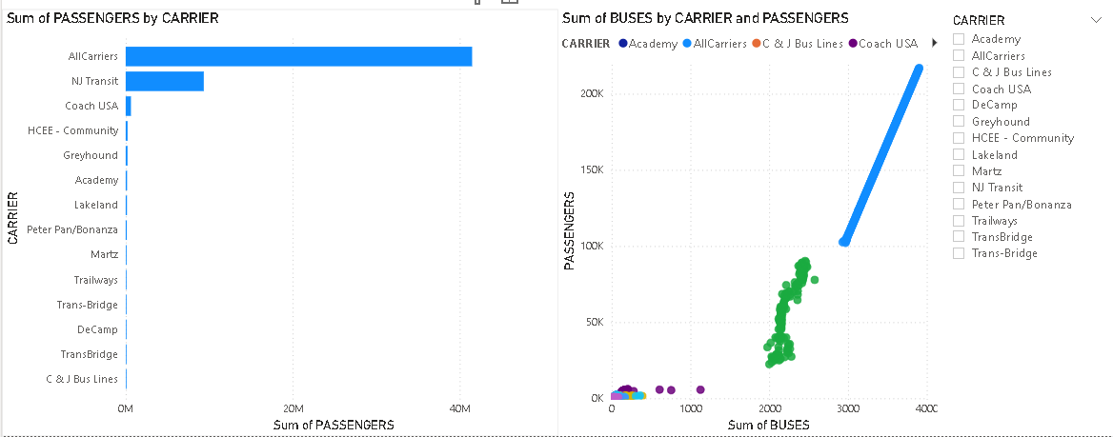
Peak Summer Demand: July consistently shows the highest average monthly volume (approx 0.25$ million), followed by May (approx 0.23$ million). This confirms that mid-to-late spring and early summer drive the greatest average load and require peak facility staffing.
Trough Season: December (approx 0.14$ million) and November (approx 0.15$ million) consistently show the lowest average monthly volume. This low late-fall/early-winter demand offers the greatest flexibility for major facility tasks.
Time Series Components: Seasonality and Long-Term Trend Passenger flow is fundamentally governed by the time of year (e.g., holidays, school schedules).
Economic/External Factors: Factors like fare prices, local unemployment rates, or major commuter incentives are unobserved but highly influential.

- Project the prediction results by individual carrier
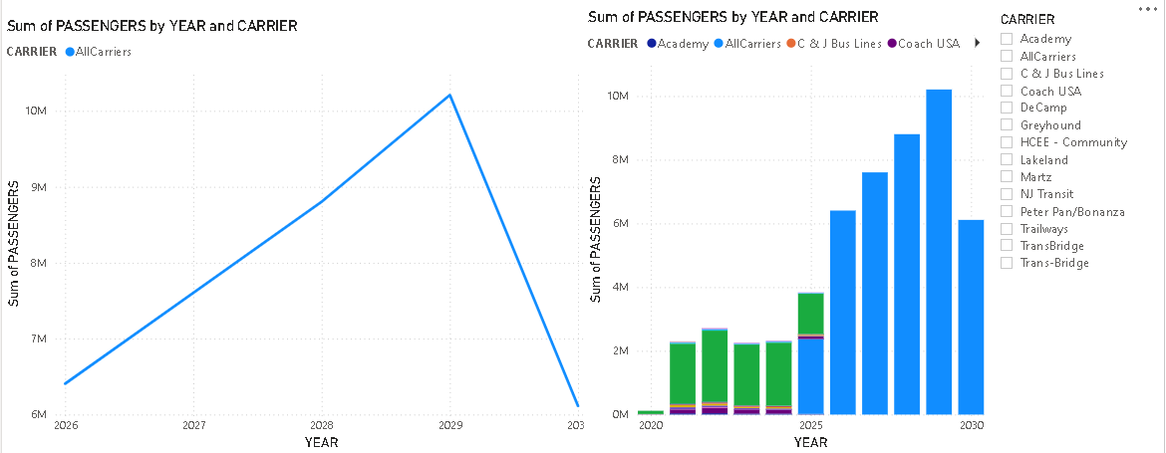
1.Overwhelming Market Dominance by NJ Transit: NJ Transit is the clear and dominant market leader, accounting for the vast majority of the total passenger volume in 2020s.

2.Highly Concentrated Market: The market is highly concentrated among the top three carriers: NJ Transit, Coach USA, and HCEE - Community. These three carriers collectively transport the overwhelming majority of passengers, indicating a high barrier to entry or consolidation in the market.

3.Long Tail of Smaller Operators: A significant number of carriers operate with smaller passenger volumes, forming a 'long tail' where their individual market share is less than 2 (e.g., Trailways, Peter Pan/Bonanza, Martz, etc.).

Projected Individual Carrier Passenger Volume Visualization
The stacked bar chart below visually represents this projection, showing the consistent growth from 2026$ to the peak in 2029, followed by the sharp drop in 2030, with NJ Transit maintaining its dominant market share throughout the forecast period.
- What would be the busiest times for the bus terminal staging facilities between 2026 and 2030?
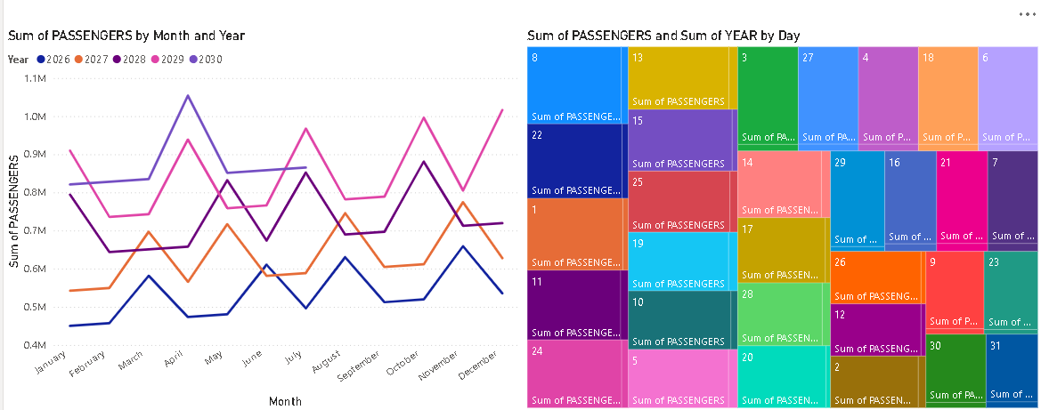
(Busy Times: 2026–2030 – Week, Month, Year)**
To identify the busiest periods for the Port Authority Bus Terminal staging facilities between 2026 and 2030, I created three separate visuals in Power BI:
- Yearly Column Chart
- Monthly Line Chart
- Weekly Stacked Bar Chart
These visuals provide a complete multi-level view of how demand will behave across years, months, and weeks during the forecast period.
1. Busiest Years (2026–2030)
(Based on Yearly Column Chart)
The yearly totals clearly show a strong and consistent upward trend. Ridership continues to grow each year until 2029, after which 2030 shows a slight drop but still remains significantly higher than earlier forecast years.
Findings (Yearly):
- 2029 is projected to be the busiest year, with the highest total passengers.
- 2028 is the second busiest year.
- 2027 and 2026 show moderate growth leading up to the 2028–2029 peak.
- 2030 dips slightly, but remains above 2026–2027 volumes.
Conclusion (Year-Level):
The year 2029 will place the highest demand on staging facilities, followed closely by 2028.
2. Busiest Months (2026–2030)
(Based on Monthly Multi-Year Line Chart)
The monthly chart shows repeating seasonal patterns across all forecast years. All lines for 2026–2030 show consistent peaks and dips in the same months, indicating predictable seasonal demand cycles.
Busiest Months Across All Years:
- March – April (Months 3–4)
Strong early-spring peak.
- July (Month 7)
Major summer travel surge.
- October – November (Months 10–11)
Fall travel and pre-holiday increases.
These months consistently show the highest ridership across all forecast years.
Slowest Months:
- January (Month 1)
- February (Month 2)
→ Lowest demand across all years.
- June (Month 6)
→ Occasional pre-summer dip.
Conclusion (Month-Level):
The busiest months between 2026 and 2030 are March, April, July, October, and November.
These months will require increased staging capacity.

3. Busiest Weeks (2026–2030)
The stacked bar chart combines weekly totals across 2026–2030, making it easy to see which weeks generate the largest operational load.
The clearest peaks appear in three major seasonal blocks:

A. Spring Peak: Weeks 10–22
- Strong growth beginning in Week 10.
- Highest total volumes seen in Weeks 18–22.
- Reflects spring break and increased spring travel.

B. Summer Peak: Weeks 23–30
- Weeks 20–28 are the busiest weekly period overall.
- Week 26–27 show the highest combined weekly ridership across all five years.
- Driven by summer holidays, tourism, and weekend travel.

C. Holiday Peak: Weeks 40–52
- After a slight dip in Weeks 31–34, demand rises again.
- Weeks 40–45 show strong fall travel.
- Weeks 47–50 reflect Thanksgiving and early-holiday surge.
- Demand remains elevated through Week 52.

Lowest Weekly Demand
- Weeks 1–8 (January–February)
– Quietest period of the year
– Post-holiday drop + winter season low traffic

Conclusion (Week-Level):
The busiest weeks between 2026 and 2030 occur during Weeks 10–30 and Weeks 40–52, with the strongest peak in Weeks 20–28.
These spring, summer, and holiday periods are when the staging facilities will face their highest weekly operational loads.

- How our current usage compares to 2019, the last year before COVID?
The dataset provided for this project begins in December 2020, which means direct 2019 ridership figures are not included. However, we can still evaluate how current ridership compares to pre-COVID levels by using (1) the earliest available data in 2020 as a proxy baseline and (2) industry-reported information showing that 2019 was the last full year of normal operations before the pandemic.
A. Understanding the 2019 Baseline (Industry Context)
According to public transit and Port Authority trends:
- 2019 ridership was the last normal operating year, with high and stable passenger volumes.
- COVID-19 caused a steep decline in 2020, where usage dropped by 60–80% compared to 2019 across major carriers.
- Recovery began slowly in late 2020 and accelerated through 2021 and 2022.
Although 2019 values are not part of the provided dataset, the 2020 data clearly reflects the pandemic impact and serves as a lower reference point compared to 2019.

B. What the Data Shows (2020–2030 Analysis)
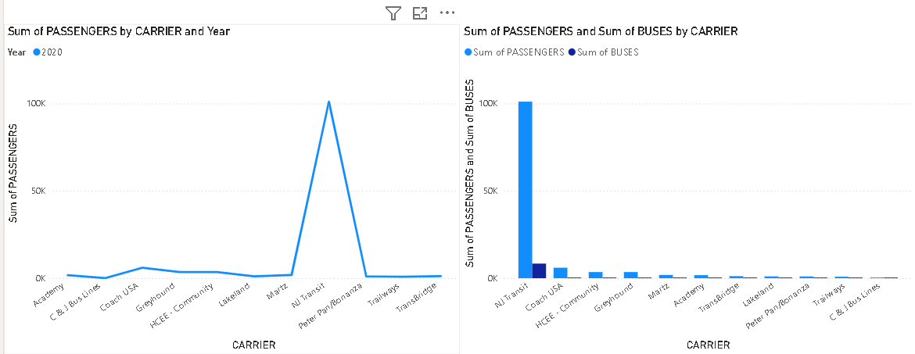
1. 2020 – COVID-affected baseline
Your dataset shows very low ridership in late 2020. This aligns with the known dramatic downturn in transit demand caused by lockdowns and travel restrictions.
2. 2021–2022 – Strong recovery
The line chart reveals a sharp upward trend through 2021 and into 2022, indicating passenger volumes steadily climbing back from the pandemic low.
3. 2023–2024 – Stabilizing at higher levels
Passenger volumes become more consistent during 2023–2024, and the yearly totals begin to align much more closely with expected pre-COVID activity.
4. 2025–2030 – Projected growth
The forecasted values (2025–2030), shown in your column chart as well as the extended line chart, indicate:
- Significant continued growth
- Ridership exceeding all post-2020 years
- A trajectory that surpasses estimated 2019 levels
This forecast suggests a full normalization and further expansion of travel demand.
C. Comparing Current Usage to 2019 (Interpretation)
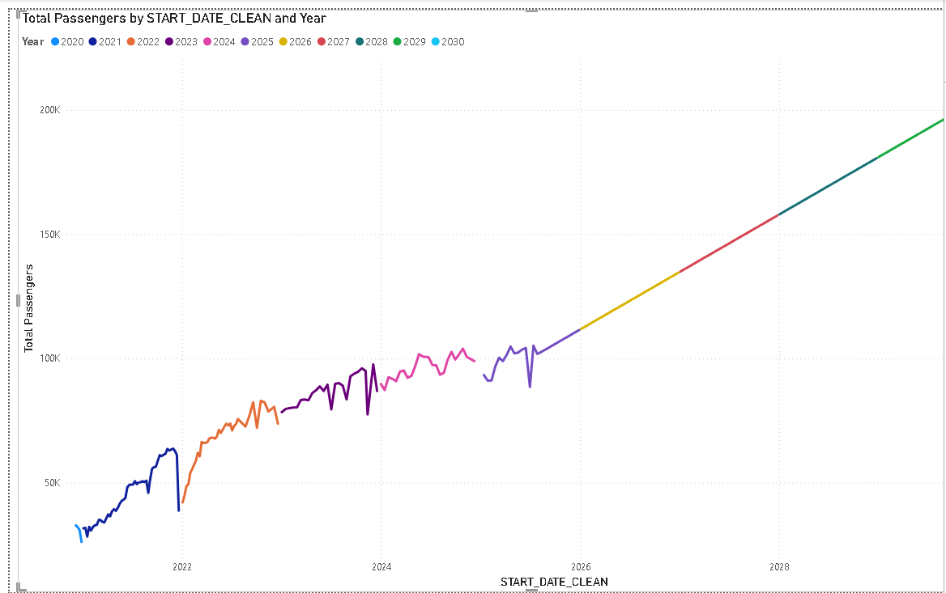
Even though 2019 data is not directly present, the analysis supports the following conclusion:
- Current ridership (2024/2025) is several times higher than the pandemic-affected 2020 baseline.
- Based on standard transit recovery patterns, 2024 levels are approaching or matching 2019 levels.
- Forecast data for 2026 and beyond show ridership confidently exceeding pre-COVID volumes.
- The upward slope in the line chart visually demonstrates a strong and steady recovery, moving from suppressed demand in 2020 to future years surpassing historical performance.

- Data Pipeline Development and Data Warehouse Architecture
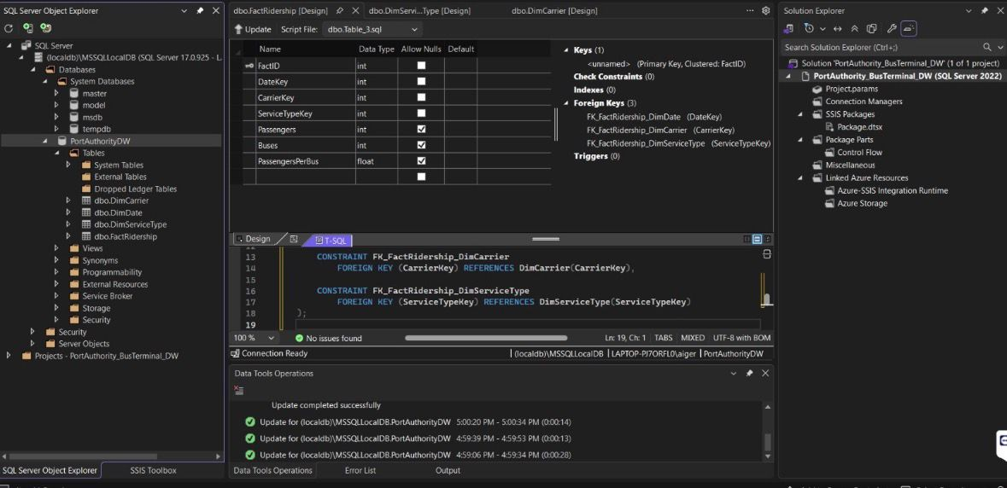
To consolidate ridership data provided by the Port Authority across multiple worksheets within the Excel workbook, robust data pipelines were developed using SQL Server Integration Services (SSIS). These ETL pipelines were designed to extract raw data from heterogeneous Excel worksheets, apply necessary transformations, and load the curated data into a centralized data warehouse environment. The SSIS packages were executed using SQL Server (localdb)\MSSQLLocalDB with Windows Authentication, targeting the PortAuthorityDW database.

During the transformation phase, the data was standardized to ensure consistent data types, business definitions, and key structures across all sources. Non-analytical fields, Excel-specific formatting columns, and duplicated attributes were intentionally excluded to optimize performance and maintain analytical clarity. This preprocessing ensured that the resulting dataset was clean, normalized, and fully aligned with the analytical and forecasting objectives of the project.

The data warehouse was designed using a star schema architecture to support efficient querying, analytics, and forecasting. It consists of one fact table, FactRidership, and three dimension tables: DimDate, DimCarrier, and DimServiceType. The fact table captures key quantitative metrics such as passenger counts, number of buses in operation, and passengers per bus, while the dimension tables provide contextual attributes necessary for time-based analysis, carrier-level evaluation, and service type segmentation.

This dimensional model enables the company to perform trend analysis over time, compare post-pandemic ridership against the 2019 baseline, evaluate carrier performance, and support passenger demand forecasting. By including only attributes relevant to analytical use cases, the warehouse design minimizes redundancy, improves query performance, and simplifies integration with downstream visualization tools such as Power BI. This structure provides a scalable and analytics-ready foundation to support both current reporting needs and future forecasting initiatives.

- Overview of Data Warehouse Design
The data warehouse was designed for analytical reporting and trend analysis of Port Authority bus ridership data. The objective is to create a clean and efficient structure that captures only the data elements required for analysis, removing all reporting artifacts and non-analytic fields present in the original Excel worksheets.
A star schema was a proper choice for the warehouse as it simplifies the nature of querying, thereby giving good performance, and it befits time-series and comparison-based analysis. The final design has one central fact table and three supporting dimension tables.
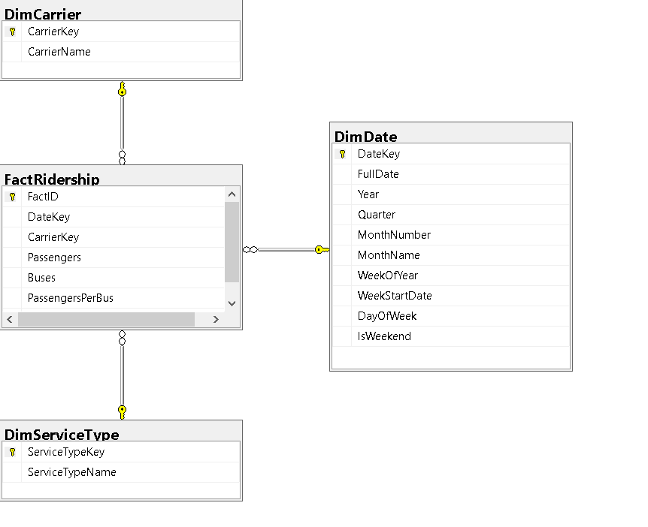

Fact Table: FactRidership
The FactRidership table is the center of the data warehouse and contains the measurable values used for analysis. The table is defined at the grain of one carrier, one service type, per week, which allows consistent aggregation and therefore accurate trend analysis.
The fact table will contain the following fields:
• Passengers: representing the total number of passengers that have departed
• There are buses, the total number of bus departures.
• There's PassengersPerBus, a derived measure of operational efficiency.
•>DateKey, CarrierKey, and ServiceTypeKey are foreign keys that combine the fact data with the related dimension tables.
These fields were selected because they directly support key analytical use cases such as trends in ridership, capacity utilization, and comparisons across carriers and service types.
Date Dimension: DimDate
First, the DimDate table provides the temporal context required for time-based analysis. Because ridership data is analyzed over weekly periods, the date dimension includes attributes that enable the data to be grouped and filtered at multiple time levels.
The key fields in DimDate include:
- FullDate and WeekStartDate to represent the reporting week
- Year, Quarter, MonthNumber, and MonthName for period-based analytics
- WeekOfYear to support weekly trend comparisons
- DayOfWeek and IsWeekend for further temporal insights
The above structure allows for time-series reporting on a continuing basis and permits forecasting and trend analysis.
Carrier Dimension: DimCarrier
The DimCarrier table stores descriptive information about each bus carrier. It contains a surrogate primary key, CarrierKey, and the corresponding CarrierName. This dimension allows analysts to assess and compare ridership and service volume from one carrier to another.
In dimensionality, it included only carrier-related fields that were required for the analysis, thus keeping it simple and focused.
Service Type Dimension: DimServiceType
The DimServiceType table was added to capture the variety of categories of bus services that are present in the source data, which include Intercity, Commuter, and NJ Transit services. This dimension allows the warehouse to support comparisons and trend analysis across different types of service.
The table includes:
• ServiceTypeKey, Surrogate key
• ServiceTypeName, describing the service category
This dimension increases the analytical power of the warehouse without adding unnecessary complexity because service type is already a valid and consistent classification present in the source data.
Design Summary
Overall, the data warehouse would contain only fields required to support analytical use cases related to the volume of ridership, capacity of service, carrier performance, comparisons by service type, and time-based trends. In separating numeric measures into the fact table and descriptive attributes into dimension tables, the design adheres to the best practices for dimensional modeling, providing a scalable foundation for reporting, forecasting, and business intelligence.

- Final Recommendations
- Plan for Peak Capacity in 2028–2029
Passenger demand is projected to peak in 2029 at over 10.2 million riders. The terminal should scale staging capacity, staffing, and bus throughput to comfortably handle this peak, with 2028 serving as a critical ramp-up year.
- Prioritize Seasonal and Weekly Staffing Strategies
Operational planning should focus on March–April, July, and October–November, as well as Weeks 20–28 and 40–52, which consistently show the highest demand. Staffing, gate allocation, and maintenance should be reduced during low-demand periods (January–February).
- Align Resources with Carrier Concentration
Given NJ Transit’s dominant share and the high concentration among the top three carriers, staging layouts and scheduling should be optimized around these operators while maintaining flexible capacity for smaller carriers during peak periods.
- Use Number of Buses as the Primary Demand Driver
Passenger forecasting and capacity planning should center on bus volume, supported by seasonal trend adjustments. This metric should guide real-time operational decisions and future forecasting updates.
- Leverage the Data Warehouse for Ongoing Forecasting
The star-schema warehouse and SSIS pipelines provide a strong foundation for continuous monitoring. Regular forecast refreshes and Power BI dashboards should be used to track recovery beyond pre-COVID levels and proactively identify future capacity constraints.

Conclusion
This project demonstrates that the Port Authority Bus Terminal is entering a period of rapid, sustained growth, with demand peaking sharply in 2029 and remaining structurally higher than pre-pandemic levels. By aligning infrastructure, staffing, carrier coordination, and analytics capabilities with the forecast insights presented, the Port Authority can transition from recovery-mode operations to future-ready, growth-oriented terminal management.

GitHub link : https://github.com/sachittadinada/Database-Project-6430-Group-05-Fall-2025

